**Results Obtained**

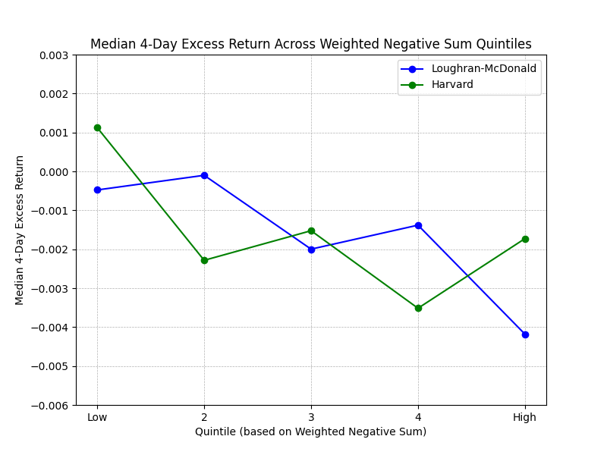

**Loughran-McDonald approach**

Mean 4-day excess returns v/s negative weights

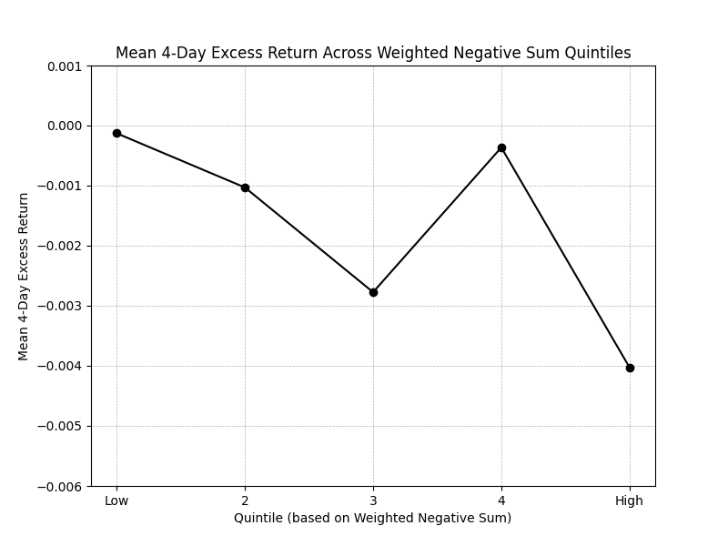

Median 4-day excess returns v/s negative weights

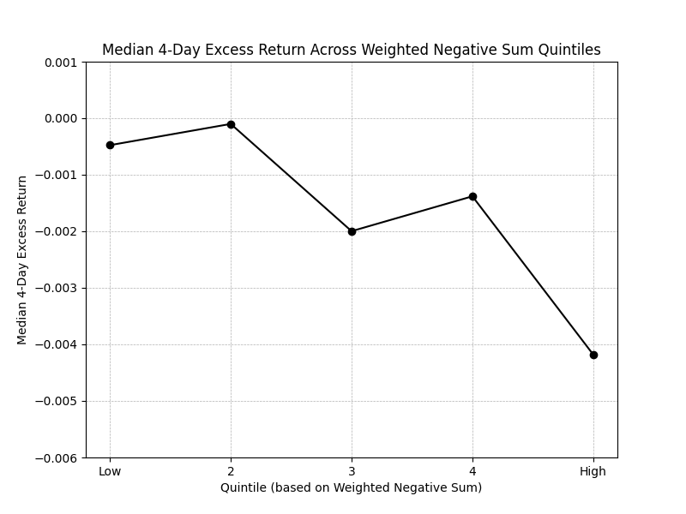

**Harvard approach**

Mean 4-day excess returns v/s negative weights

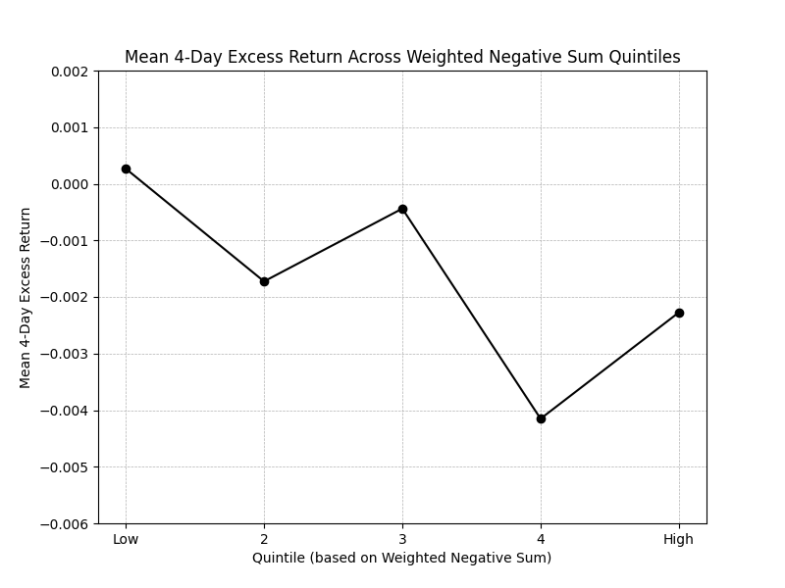

Median 4-day excess returns v/s negative weights

